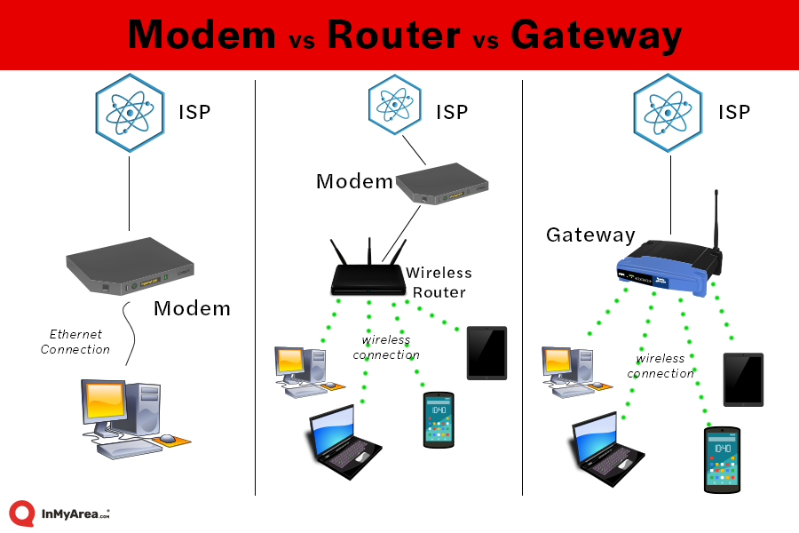
A WiFi gateway is a single hardware device that functions as both a modem and a router, acting as the central hub that connects your home's local network to the internet. It translates data signals between your home network and your Internet Service Provider (ISP), providing Wi-Fi to your devices and managing data flow to ensure seamless internet access for activities like streaming, gaming, and video conferencing
- Combines Modem and Router: A gateway integrates the capabilities of a modem (which connects your network to your ISP) and a router (which creates your private network and allows devices to share the internet connection) into one device.\
- Connects to the Internet: It acts as the entry point from your internal network to the wider internet, translating data between different network types and protocols.
- Provides Wi-Fi: The gateway serves as a wireless access point, broadcasting the Wi-Fi signal that your devices use to connect to the internet without physical cables.
- Manages Network Traffic: It manages the flow of data, directing traffic between your various internet-connected devices and the internet, which can significantly impact speed, reliability, and performance.
A multi-protocol gateway converts data from different wireless protocols, such as Bluetooth Low Energy (BLE), Thread, and Zigbee, into Ethernet and Wi-Fi signals.
This allows smart devices that use these low-power protocols to communicate with other devices and applications over a standard internet connection.
SDR will function as the gateway. Since some parts will need replacement, the items of other gateways will serve as this replacement for the SDR.

